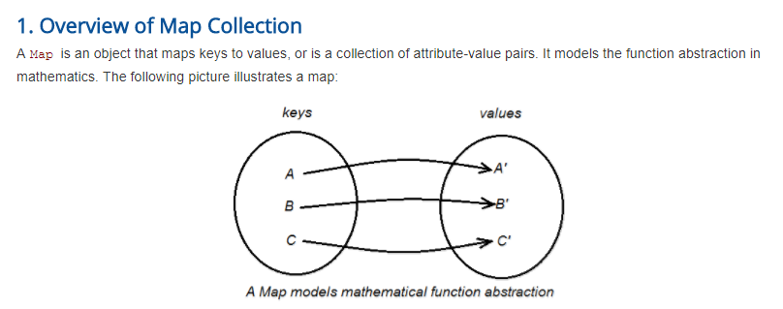

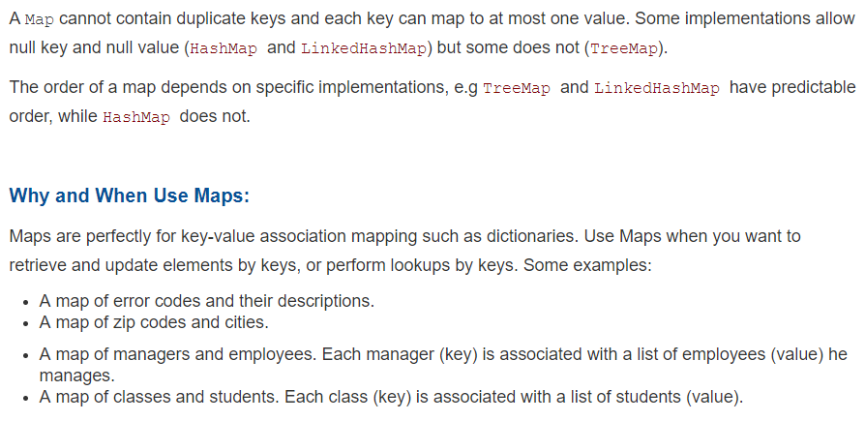

**2. Creating a new Map**

**Creating a HashMap:**

Always use interface type (Map), generics and diamond operator to declare a new map. The following code creates a HashMap:

|  |  |
| --- | --- |
| 1  2  3  4  5  6  7  8 | Map<Integer, String> mapHttpErrors = new HashMap<>();    mapHttpErrors.put(200, "OK");  mapHttpErrors.put(303, "See Other");  mapHttpErrors.put(404, "Not Found");  mapHttpErrors.put(500, "Internal Server Error");    System.out.println(mapHttpErrors); |

This maps HTTP status codes to their descriptions. Output:

|  |  |
| --- | --- |
| 1 | {404=Not Found, 500=Internal Server Error, 200=OK, 303=See Other} |

As you can see in the output, a HashMap does not impose any order on its key-value elements.

**3. Iterating Over a Map (using Collection views)**

As a Map is not a true collection, there is no direct method for iterating over a map. Instead, we can iterate over a map using its collection views. Any Map’s implementation has to provide the following three Collection view methods:

* **keySet()**: returns a Set view of the keys contained in the map. Hence we can iterate over the keys of the map as shown in the following example:

|  |  |
| --- | --- |
| 1  2  3  4  5  6  7  8  9  10  11  12  13  14  15  16 | Map<String, String> mapCountryCodes = new HashMap<>();    mapCountryCodes.put("1", "USA");  mapCountryCodes.put("44", "United Kingdom");  mapCountryCodes.put("33", "France");  mapCountryCodes.put("81", "Japan");    Set<String> setCodes = mapCountryCodes.keySet();  Iterator<String> iterator = setCodes.iterator();    while (iterator.hasNext()) {      String code = iterator.next();      String country = mapCountryCodes.get(code);        System.out.println(code + " => " + country);  } |

Output:

|  |  |
| --- | --- |
| 1  2  3  4 | 44 => United Kingdom  33 => France  1 => USA  81 => Japan |

* **values()**: returns a collection of values contained in the map. Thus we can iterate over values of the map like this:

|  |  |
| --- | --- |
| 1  2  3  4  5 | Collection<String> countries = mapCountryCodes.values();    for (String country : countries) {      System.out.println(country);  } |

* Output:

|  |  |
| --- | --- |
| 1  2  3  4 | United Kingdom  France  USA  Japan |

* **entrySet()**: returns a Set view of the mappings contained in this map. Therefore we can iterate over mappings in the map like this:

|  |  |
| --- | --- |
| 1  2  3  4  5  6  7  8 | Set<Map.Entry<String, String>> entries = mapCountryCodes.entrySet();    for (Map.Entry<String, String> entry : entries) {      String code = entry.getKey();      String country = entry.getValue();        System.out.println(code + " => " + country);  } |

Output:

|  |  |
| --- | --- |
| 1  2  3  4 | 44 => United Kingdom  33 => France  1 => USA  81 => Japan |